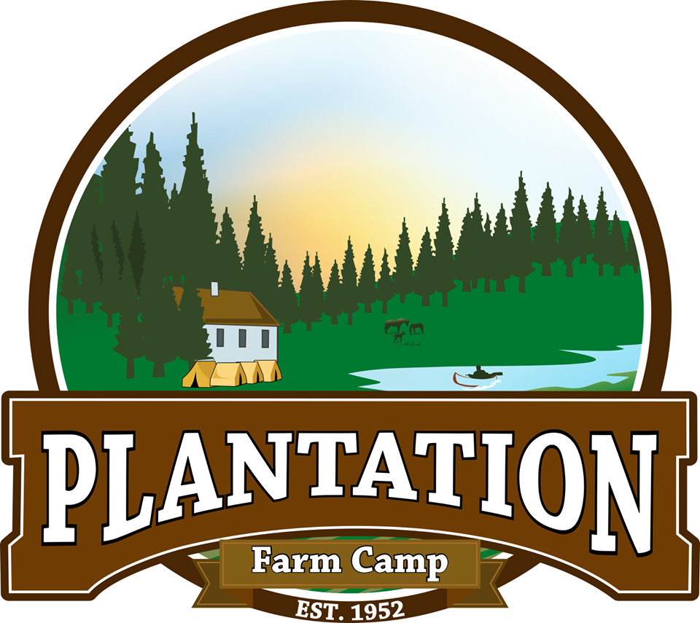

CAMP ENCYLOPEDIA

Some names, places and explanations to help you feel at home at Plantation Camp
(Originally compiled in 1991 by Carl Hammarskjöld.)

Camper Units:
Berriwood – The oldest girls’ unit, located behind Druids Hall.
Alpine – The second oldest girls’ unit, high up in the Alpine Meadow with its own redwood circle.
Millers Gulch – The second youngest girls’ unit, located in a canyon carved out by the creek.
Sunny Hill – The youngest girls’ unit, in the Alpine Meadow across the road from Druids Hall.
Deep Woods – The oldest boys’ unit, located in a wooded gully.
Earwig – The second oldest boys’ unit, on a grassy slope behind the garden.
Sequameadow – The second youngest boys’ unit, distinguished by a nearby giant stump.
Cherry Boys – The youngest boys’ unit, in a field bordered on one side by blackberry bushes and a cherry plum tree.

Alpine Hotel – A circle of redwoods forming a shaded canopy in the middle of the grassy Meadow.
Apple Dryer – The site of one of the original camper units in the 1950’s when Plantation Ranch was first made a summer camp by Abe and Eve Crittenden. The Apple Dryer now stores food, costumes and the camp store during the summer and camping equipment during the rest of the year.

Brown’s House – David and Suzanne Brown own Plantation and are former directors. They love camp, and may be around to participate in camp, but their home right next to the Patio is off limits.

CILT Unit – CILT means Campers-In-Leadership-Training. This unit is for older (15+) campers who are building their wilderness and leadership skills. They camp at a secluded site in teepees.
Corral – Home to horse orientation during the first few days of camp and home for goats or sheep in the winter. The old Plantation House used to stand here before it burned down. The House was a popular hotel and stagecoach stop during the early settlement days.
Cow Barn – The milking station. A heavy-duty wood and concrete structure designed to store hay in the summer and create a pleasant home base for Cow Chore, other “upper” chores, and Sheep Shearing.
Crittenden Bench – Situated above the Pool looking out over camp, this beautiful Bruce Johnson sculptured bench commemorates Abe, Eve, and Tony Crittenden, founders of Plantation Farm Camp.

Druids Hall – Built over a century ago, Druids has undergone many renovations and remains a reminder of Plantation’s history. Before that it served as a community center. Good books.

Garage – Storage area attached to the hay barn for the tractor, lawnmower, and basketballs.
Garden – Lots of delicious vegetables and berries and beautiful flowers come via Garden Chore to the dinner table. Corn, cucumbers, lettuce, beans, and tomatoes are just the first course. The garden is considered a building – kids need a counselor to enter.

Hay Barn – A focal point of camp. Saturday night barn dances and some dramas go on in this, one of the oldest structures at Plantation. The floor shakes under the weight of 100 well-fed campers and the barn swallows may frost your hair. The McKenna brothers, notorious for their schemes and pranks, carved their initials into the barn wall near the front entrance, and the markings are still there.

Ice House – A storage house for paint and recyclables. During the hotel days, huge blocks of ice made their way to this shady hut, making Plantation the only place for miles where a weary traveler could get a cold drink.
Infirmary – This trailer is where to go if you need some minor medical attention. First aid and bee sting kits are kept here, along with the campers’ medicines.

Kitchen – Where the food is prepared and served. When the Crittendens took charge of Plantation, this entire building was totally obscured by overgrown bushes. Just outside the kitchen, on the patio, is a century-old rose bush that still remains.
Kruse Ranch Road – Important to remember that this is a county road and folks may cruise down it especially on summer weekends. To the west is the Kruse Rhododendron State Researve, to the east is Seaview Road.

Mother Goose and Saddle Mountain – Redwood sculptures in the front lawn created for Plantation by local artist Bruce Johnson.
Mud House – This house is where the Ranch Manager lives and is the first building on your left as you come into Plantation. It’s the oldest building on the property. It got its name not because it is made of mud, but because a winter flood filled it knee-deep with mud decades ago.
Music Room – Next to the kitchen, musical instruments are kept for counselors and campers alike.

Office – The business site of Plantation, located next to the camp kitchen. Home incoming mail, supplies and Director working space.
Osprey House – Another Bruce Johnson creation. A wonderful spot for sprouting the artistic imaginations of campers and counselors. It’s nestled down in the Boys’ meadow.

Patio – Where we eat lots of great food, have morning singing, do activities, and more.
Pool Stage– We had to take advantage of this wonderful view, so this is where the pool and pool-house rooftop stage are located.

San Andreas Fault – Famous the world over. After the disastrous 1906 quake that crippled San Francisco, geologists worked their way up the fault to Plantation studying the extent of the trembler. They found a cow, four legs sticking up stiff in the air, apparently half swallowed up by the fault. In fact, the animal had died days earlier and was planted in the crack by the McKenna brothers to hoodwink the big-city scientists. Photos of the fake quake victim appeared in geography textbooks for years, some still in use today.
Scrap Wood Pile – This wood is fair game for any kind of project, including boat building, bench making, or tent improvements. It is located next to the shop.

Shop – The shop is a gold mine of hammers, nails, shovels, drills, hatchets, and other tools that can turn any unit into a second home. Tools must be checked out so they don’t disappear. kids can’t go in without a counselor (as with any building).
Sterilizer – Where the meal dishes are cleaned and sterilized.

Tack Room – The part of the hay barn reserved for horse equipment.
Tony’s Tree – This enormous redwood was struck by lightning and burned clear through its middle – but the hollowed out tree still lives and grows. Inside, a small room has been created, complete with electricity, a bed, and a wood stove. Tony’s Tree was originally called Peter’s Tree (after a Peter Pan drama performed under its mighty boughs), but was renamed after Tony Crittenden, who grew up with this tree.
Truck Barn – barn next to the shop. Used as a dry workplace in the winter and home to art and other camper activities.

Volleyball Court – A playing field, this is also where the camp assembles when the fire or earthquake warning is blown on the air horn.

Wendy’s Tree – Tony’s Tree’s companion in the Alpine Meadow, named after Wendy in Peter Pan, located by the pig pen.
Wash Area – Wash buckets are assembled behind the kitchen after meals. Also, trash is identified and separated into compost (inedible organic), pig bucket (edible organic), Recycle and trash.
Water Tanks – Two 10,000 gallon concrete tanks supply Plantation with drinking water for cooking, cleaning and drinking. Known as the “good water”, it comes from a reliable, pure spring. Water that comes from red pipes or faucets, however, is for animals only, and comes from a reservoir way up past the CILT unit.

As you learn your way around Plantation Camp, please add to this list!

(Revised 2014)

